Technical Documentation for DevOps pipeline creation for Curaas (Curam-as-a-Service)

Table of Contents

Executive Summary 2

Architecture Diagram 2

OpenShift Configuration 2

Tekton Pipeline Setup Instructions 3

Argo CD Setup 10

Setting Up a New Environment 15

Running pipeline 15

Curam Pipeline Requirements 15

Source Code Repo 15

Pipeline Build Files 15

Appendices 15

ConfigMap and Secrets 16

Troubleshooting 16

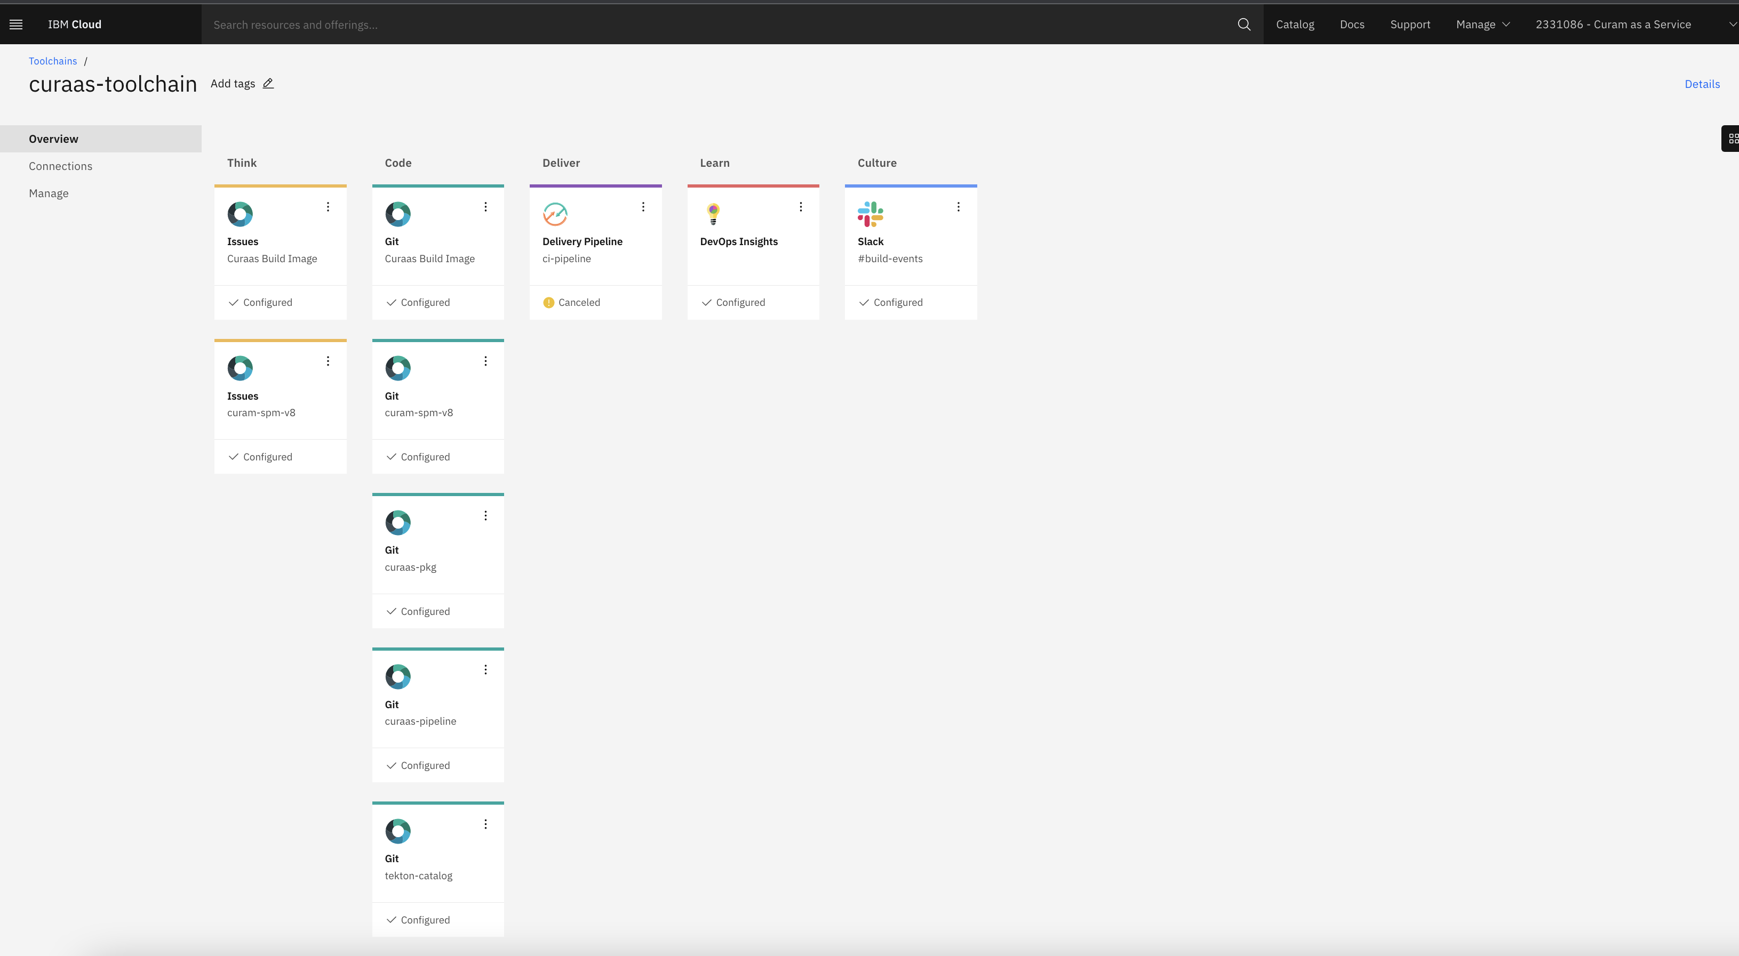

# Executive Summary

Curam-as-a-Service offers fully supported platform where an individual team is not required to install and maintain the infrastructure.

This document has been created with all instructions to provision the on-demand environments, build CI/CD pipelines, and deploy the applications into respective environments.

Following the below detailed instructions would help an individual or team to build/deploy the fully supported platform.

# Architecture Diagram

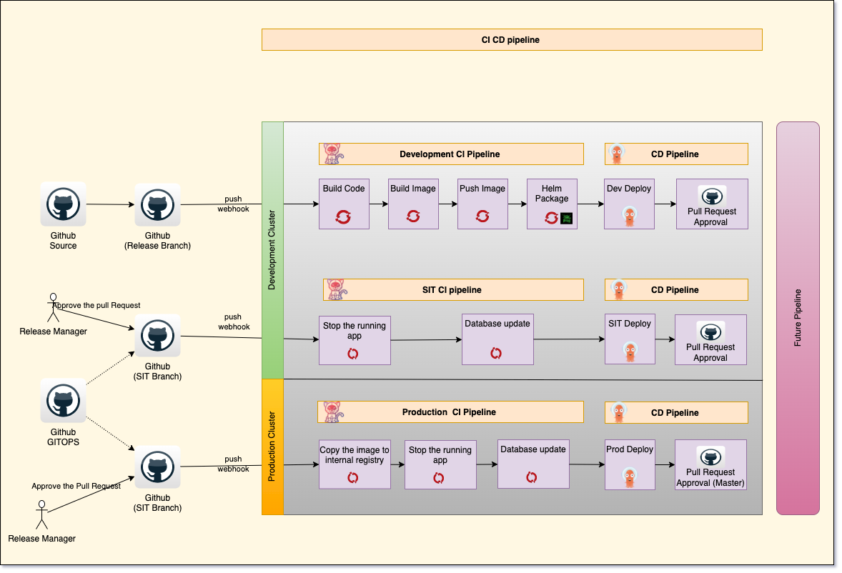

* GitHub: This component is used to store the source code for application ,GitOps and Helm Chart
* Jfrog: All Helm Chart are stored in the internal Jfrog artifactory
* ArgoCD: This Component is used to deploy the application in OCP Cluster . It has been added as part of Continuous deployment for the pipeline.
* Tekton : This Component has been used to create the CI pipeline.

# OpenShift Configuration

This document won’t go into installation instructions as the OpenShift intall can vary between Cloud Provider (ROKS vs ROSA for example). Once OpenShift has been installed, the following configurations are required:

# Tekton Pipeline Setup Instructions

In Phase 2, DevOps team had transferred CI pipeline from DevOps toolchain to inside OCP cluster along with updating a CD (Continuous Deployment) pipeline for the Curam application.

Below are some useful locations.

IBM Cloud location can be found at <https://cloud.ibm.com/>

|  |  |
| --- | --- |
| Cloud Account Used for Curaas | 2331086 – Curam as a Service |
| Curam-spm-v8 (source code repo) | <https://github.ibm.com/Michael-Wallach/SPMEight> |
| Curaas GitOps repo | <https://github.ibm.com/Michael-Wallach/Gitops> |
| OCP Cluster for DevOps pipeline | roks-workload-ocp-public |
| Cluster location | <https://console-openshift-console.roks-workload-ocp-public-ed1a03814f096c1e0c48d0de41f5ae2b-0000.ca-tor.containers.appdomain.cloud/> |
| Cloud Native Toolkit Instructions | <https://cloudnativetoolkit.dev/setup/fast-start/> |
| DevOps pipeline source code | https://github.ibm.com/Michael-Wallach/Curam-pipelines-tasks.git |
| Helm chart repo | https://github.ibm.com/Michael-Wallach/curaas-pkg.git |

1. Access the provisioned Cluster by going to IBM Cloud Account and selecting the Cluster under that account.

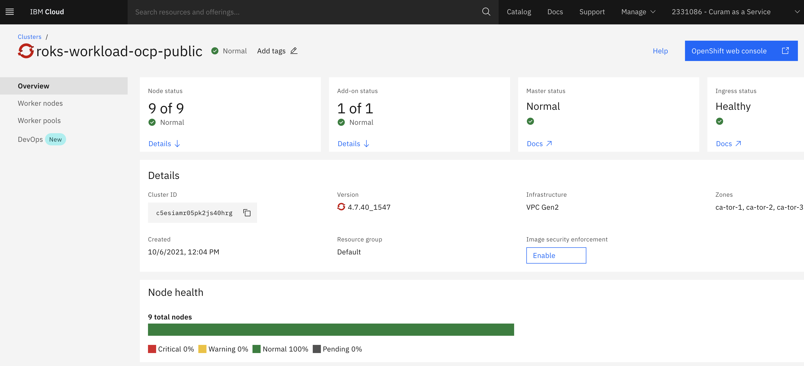

1. Access OpenShift Console by clicking on “OpenShift web console” button on the top right corner in blue color.

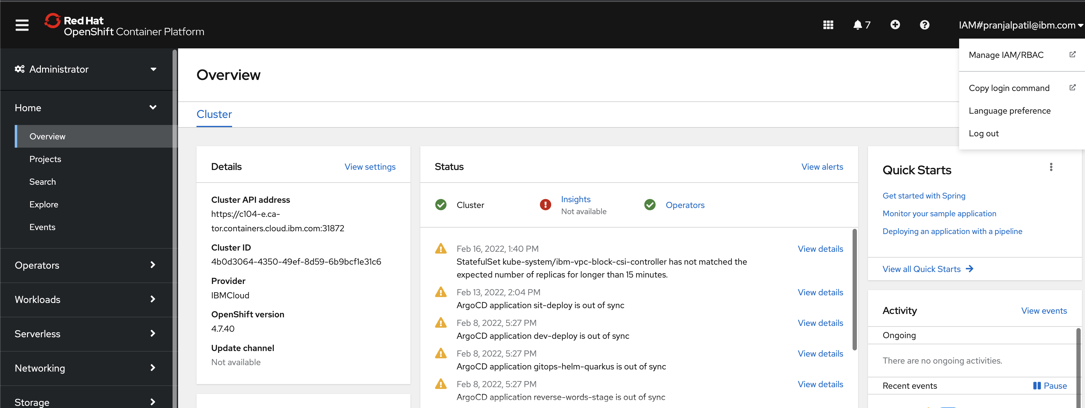

1. Access the Console using CLI by running below instructions.
   1. Click on the name at the top right corner as shown in above image and click “Copy Login Command” option.
   2. Click on Display token which will display the token that will be used for CLI login.
   3. Use the command given under “Login with this token” section.
2. Once OCP CLI login is successful, please follow below instructions in order to install Cloud Native Toolkit.
   1. Run “curl -sfL get.cloudnativetoolkit.dev | sh -“ command for installation. This could take several minutes based on the connectivity.
3. Once the toolkit is installed successfully, 9 dot in grid can be displayed at the top right side. Clicking on that grid icon will expand the tools installed during step 4.

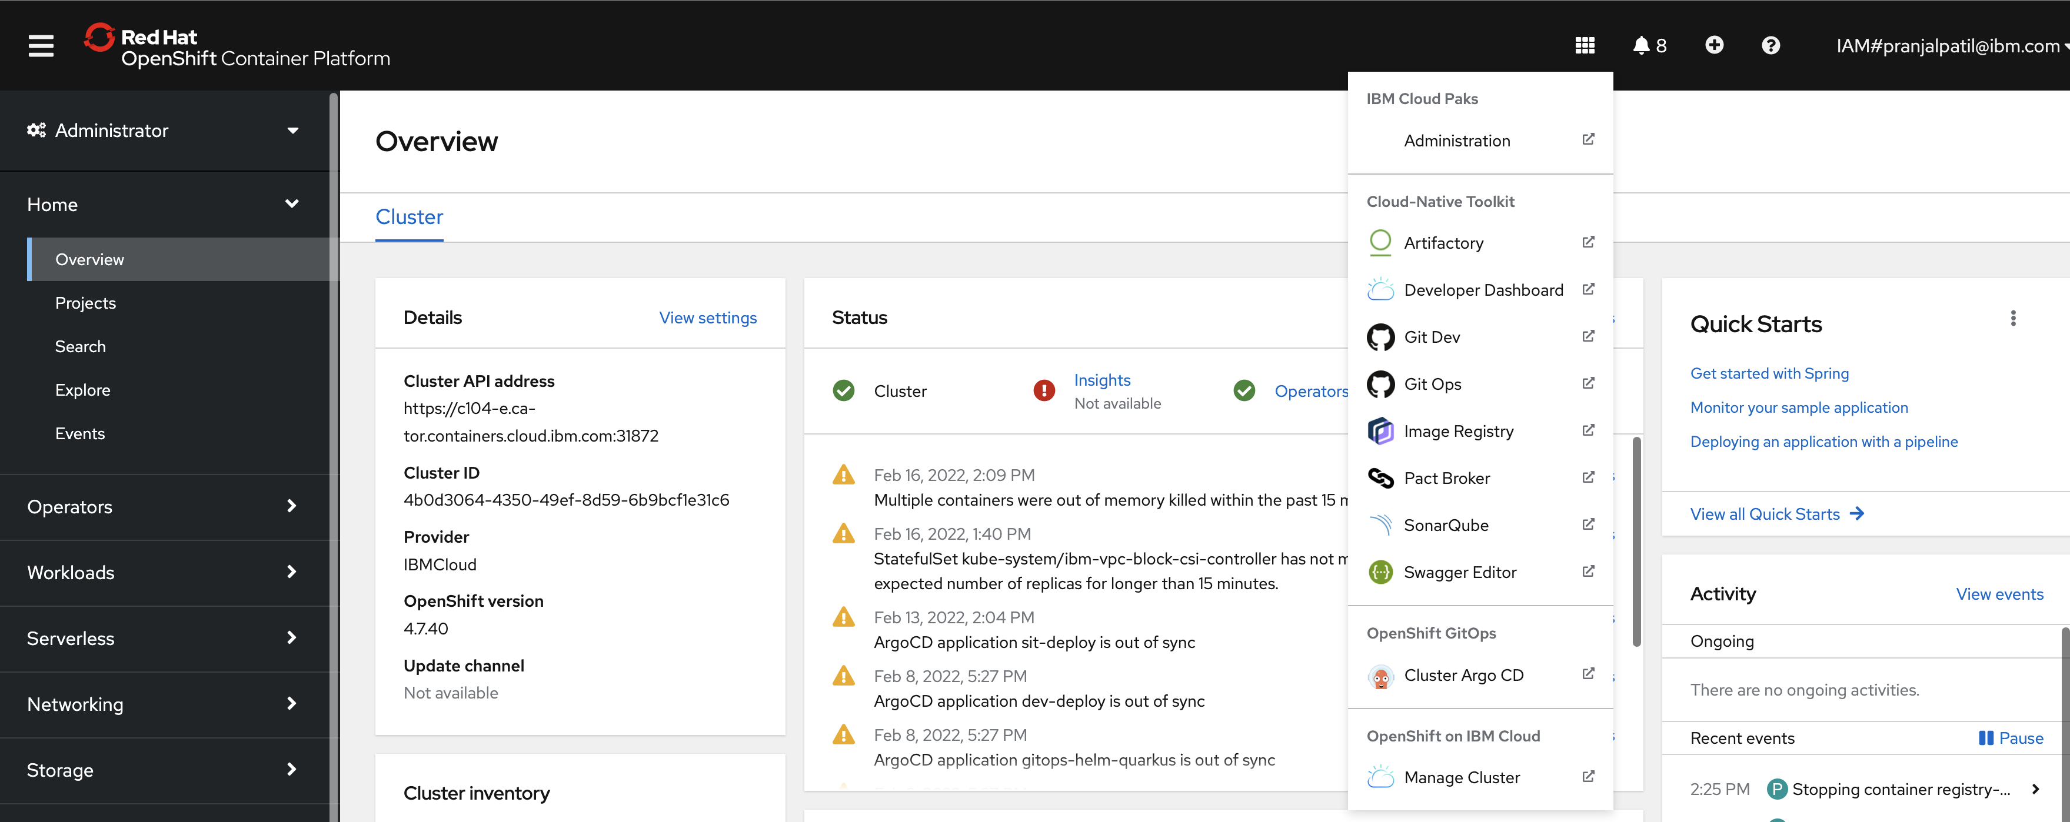

1. Once changes are pushed to application repo, a pipeline will be triggered to some instructions based on the requirement.
   1. Pipeline will build the application code and create helm charts for the deployment.
   2. Helm charts will be pushed to artifactory as well as GitOps repo for the CD part.

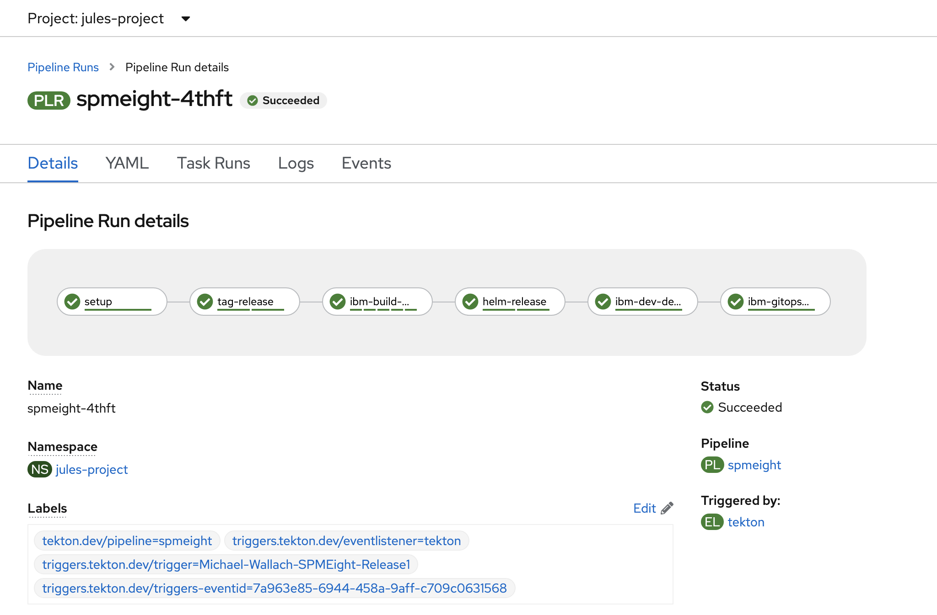

1. Click on “Cluster Argo CD” tool name from OCP console as show in step 5 and it will redirect you to CD part.

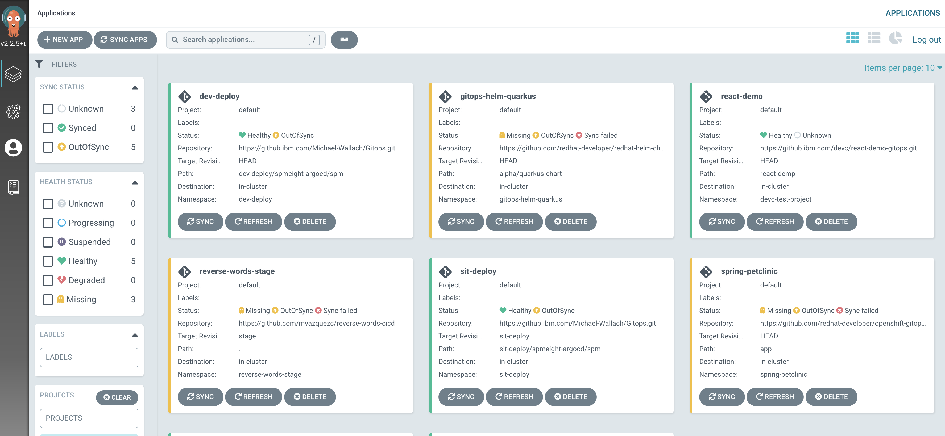

1. Please follow below instructions in order to create a app in Argo CD.
   1. Click on “New App” at top left side.
   2. Fill the details in below screen as per project requirement. Please note, that the details filled are for coaching purpose only.

**Note:-** Please make sure to enter GitOps repo as path under Source section. GitOps repo or any repo where the helm charts are available for the application.

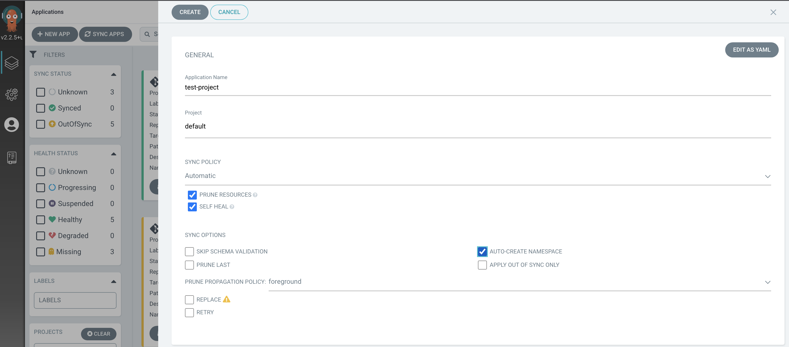

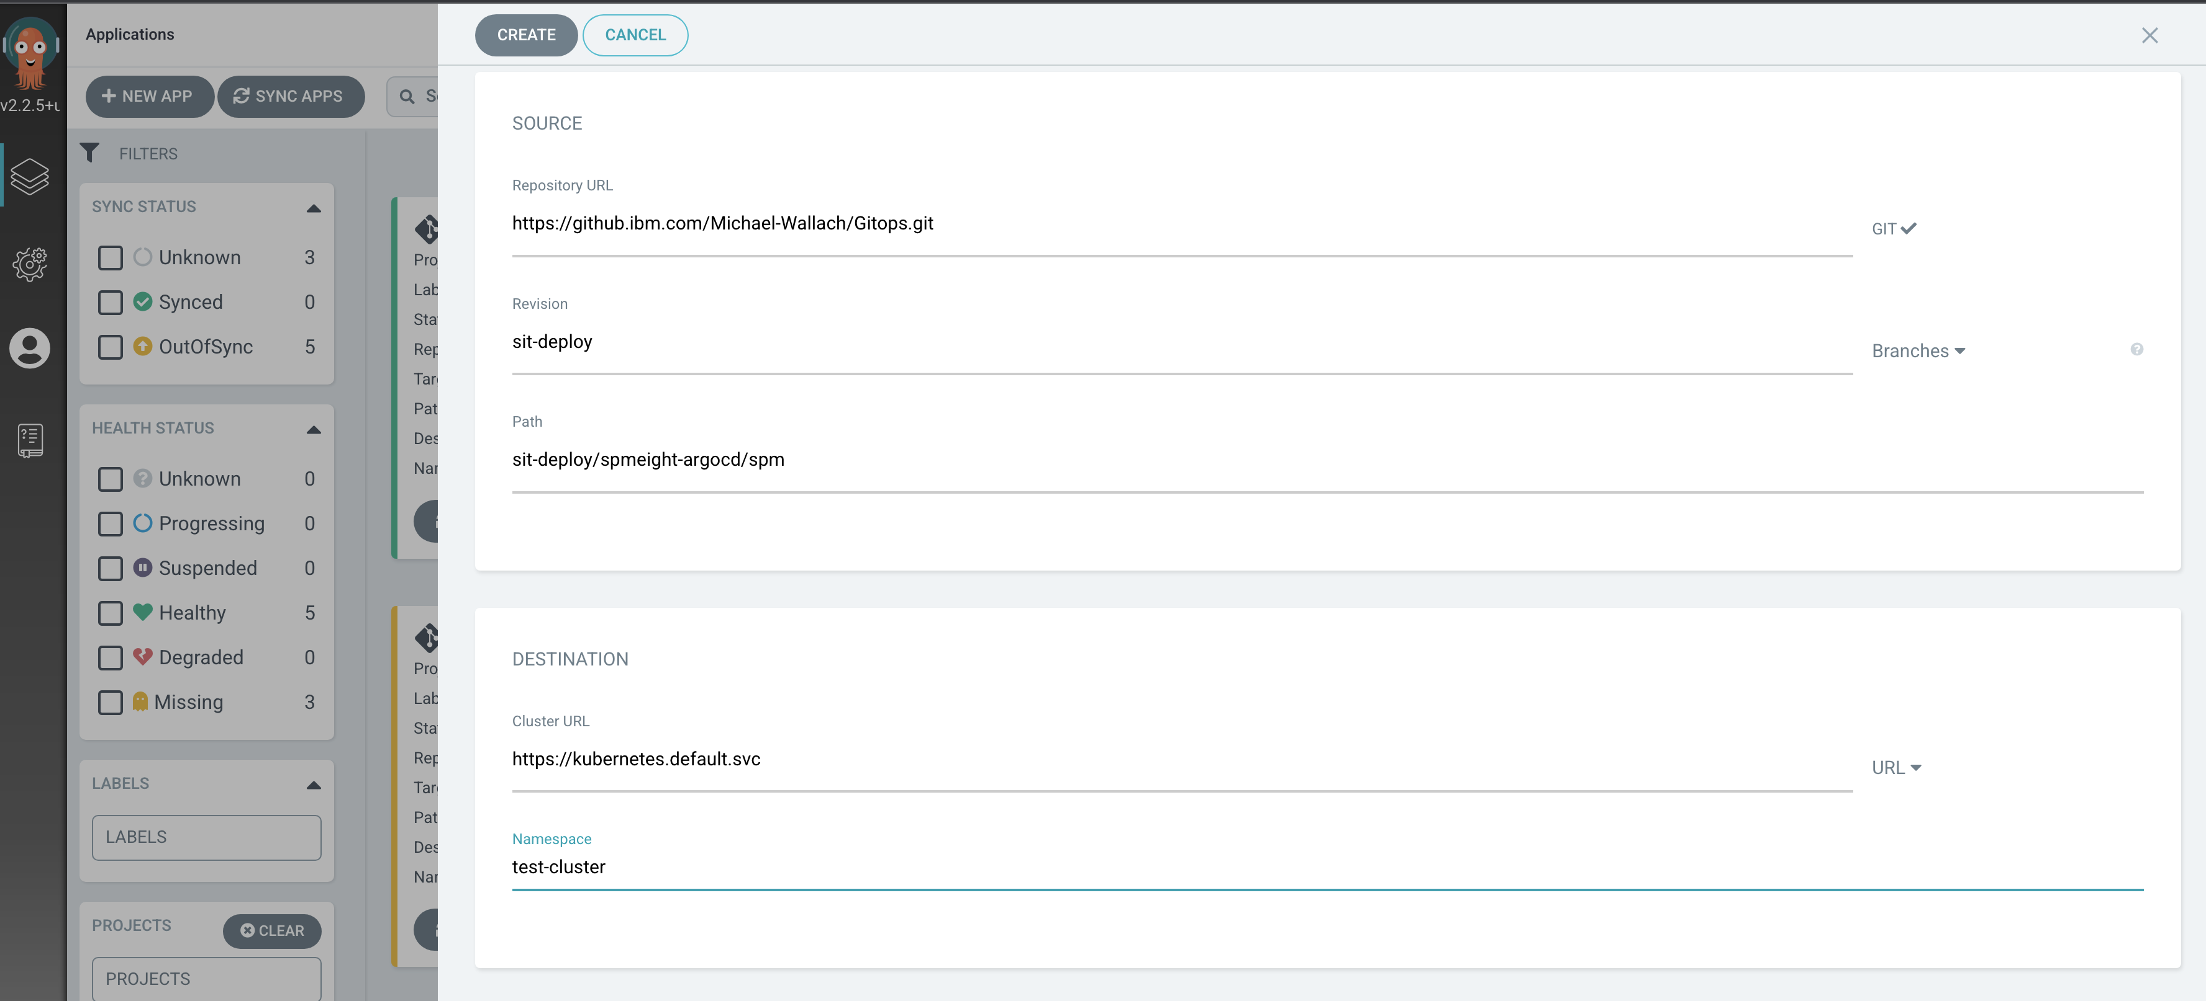

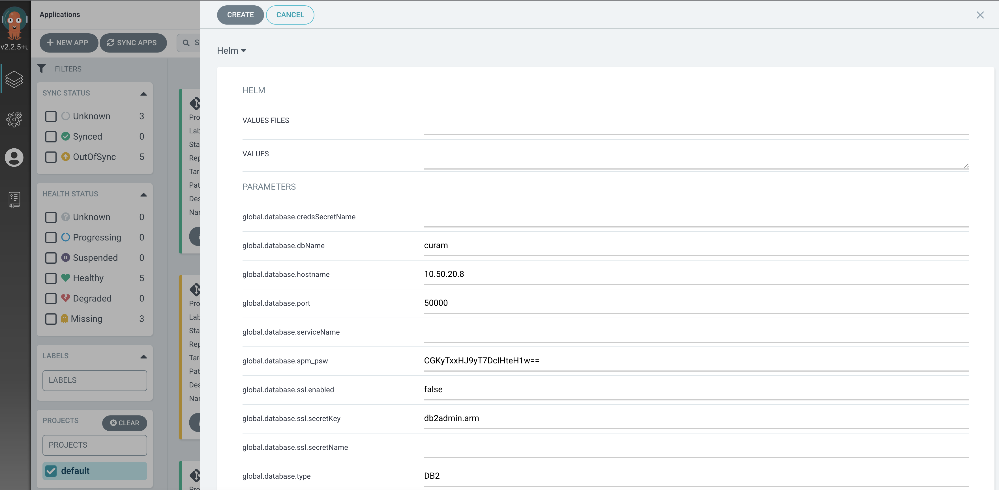

* 1. Once you fill all details, click on Create button. This will help creating the application.
  2. Since Sync Policy has been selected as Automatic, please wait for few minutes to have the application deployed.
  3. Once application is deployed, you can see the ArgoCD as shown below.

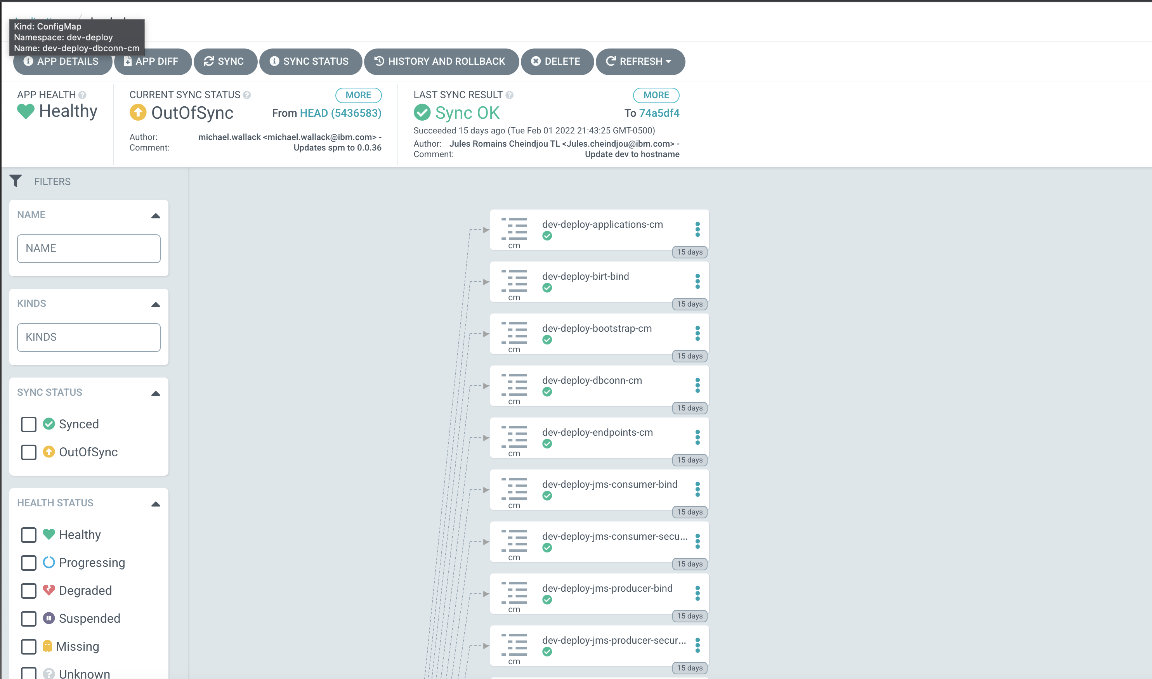

# Argo CD Setup

1. Access the provisioned Cluster by going to IBM Cloud Account and selecting the Cluster under that account.



1. Access OpenShift Console by clicking on “OpenShift web console” button on the top right corner in blue color.



1. Access the Console using CLI by running below instructions.
   1. Click on the name at the top right corner as shown in above image and click “Copy Login Command” option.
   2. Click on Display token which will display the token that will be used for CLI login.
   3. Use the command given under “Login with this token” section.
2. Once OCP CLI login is successful, please follow below instructions in order to install Cloud Native Toolkit.
   1. Run “curl -sfL get.cloudnativetoolkit.dev | sh -“ command for installation. This could take several minutes based on the connectivity.
3. Once the toolkit is installed successfully, 9 dot in grid can be displayed at the top right side. Clicking on that grid icon will expand the tools installed during step 4.



1. Click on “Cluster Argo CD” tool name and it will redirect you to CD part.



1. Please follow below instructions in order to create a app in Argo CD.
   1. Click on “New App” at top left side.
   2. Fill the details in below screen as per project requirement. Please note, that the details filled are for coaching purpose only.

**Note:-** Please make sure to enter GitOps repo as path under Source section. GitOps repo or any repo where the helm charts are available for the application.







* 1. Once you fill all details, click on Create button. This will help creating the application.
  2. Since Sync Policy has been selected as Automatic, please wait for few minutes to have the application deployed.
  3. Once application is deployed, you can see the ArgoCD as shown below.



# Setting Up a New Environment

Need the instructions for setting up a new environment. There is the main pipeline for the dev environment but my understanding is that there is a pipeline required for each new environment. SIT, UAT etc…

Note:

* Please review all the tasks files and update the manifest file.(Any line referenced with comment)
* The artifactory url should be updated in gitOps repo branch and in ocp artifactory configmap in the Dev ENV to match to public url .
* Image registry is internal .However you can also use the external image registry.
* Create the docker images and push it to your image registry . (Dockerfiles are available in DevOps pipeline repo)

## Project namespace creation

Login the OCP and run the command oc new project “namespace name”

## Create pipeline task

Note: before creating the tekton you have to create and update the image registry path on that file. Tekton task files are available in the << DevOps pipeline source code >>

* Select the project namespace: oc project “pipeline project namespace name”
* Clone the repo : git clone << DevOps pipeline source code >>
* Review all tekton task files available in that repo. ( objet kind is referenced as Task).
* Run oc apply -f << file name >> to create the task.

## Create Tekton CI pipeline

Note: Please create a default pipeline using Cloud native tools kit

* Clone the source code repo : git clone << source code repo url >>

Change to git directory: cd << repo name>>

* On the pipeline project namespace run command: oc pipeline –tekton and follow the prompt . Provide git credentials and choose nodejs as pipeline template
* Review the << DevOps pipeline source code>> repo to get the pipeline file.( object kind is referenced as pipeline)
* Run oc apply -f “pipeline file” to overwrite the default pipeline” ( this command will overwrite the configuration of the default pipeline that you have created previously). We can also customize the pipeline by adding or removing task from OCP console.

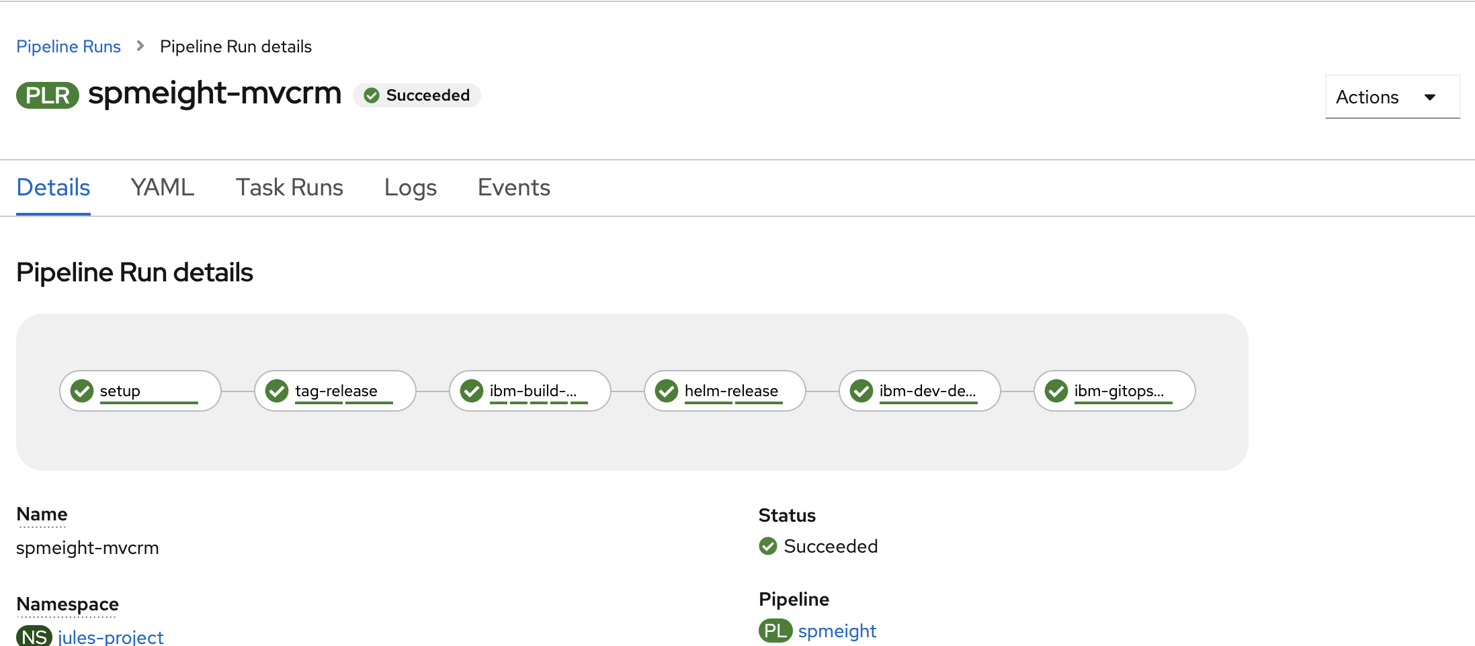

## Create ENV pipeline to deploy in dev ,test ,prod

Note : please create the project namespace first.

* Review the Devops pipeline source code to get those pipeline files.(ie sit-promotion.yaml)
* Run oc apply -f “file name” ( you can rename the pipeline as you like)

Example.



## Update the pipeline trigger

The default trigger exists and need to be updated.

Review the Devops pipeline source code repo and get the triggers files (objet kind referenced as TriggerTemplate)

* Update that file with all references to match your pipeline.
* Run oc apply -f “triggers file”
* Launch the OCP console and choose the project pipeline namespace.
* In the pipeline section, choose triggers .
* Click on EventListener and open tekton.
* Update or add the binding for each env on the yaml file associated to Tekton

Example

- bindings:

- kind: TriggerBinding

ref: trigger-binding

interceptors:

- cel:

filter: >-

header.match('X-GitHub-Event', 'push') && body.ref ==

'refs/heads/prod' && body.repository.full_name ==

'<< gitOps repo name>>'

name: << add the pipeline name>>

template:

ref: << trigger template name>>

Example.

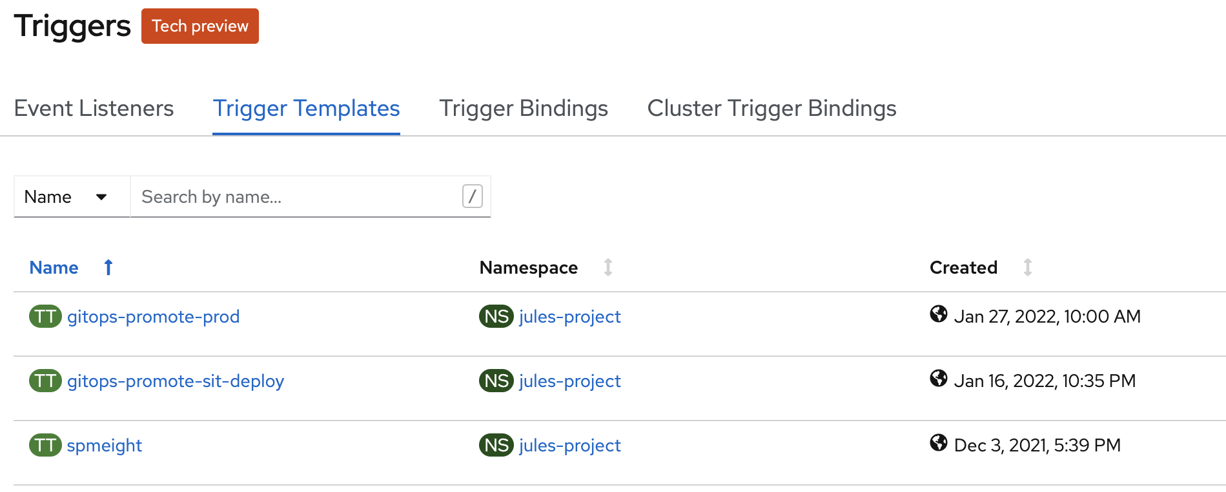

# Helm Chart requirement

# Helm chart is used SPM package as the umbrella. Please update the dependencies as follow:

# Open the helm chart folder in the github repo

# Launch Chart.yaml in the SPM folder.

# Update the dependencies section.

|  |
| --- |
| dependencies: |
|  | - name: apps |
|  | version: "~replace" |
|  | repository: "@<<your repo name>>" |
|  | - name: batch |
|  | version: "~replace" |
|  | repository: "@<<your repo name>>" |
|  |
|  |
|  |
|  | - name: web |
|  | version: "~replace" |
|  | repository: "@<<your repo name>>" |
|  | - name: mqserver |
|  | version: "~replace" |
|  | repository: "@<<your repo name>>" |
|  | - name: xmlserver |
|  | version: "~replace" |
|  | repository: "@<<your repo name>>" |
|  | - name: ibm-sch |
|  | repository: "@sch" |
|  | version: "^1.2.19" |
|  | alias: sch |

# "@<<your repo name>>" should be the same name used for OCP pipeline project namespace.

# Running pipeline

Tekton pipeline triggers and kick off when there is a commit on << source code repo branch>>. However it can also be kicked off from ocp command line : tkn pipeline start “pipeline name” --timeout 2h30m0s

Note: Tekton cli need to be installed on your local in order to run that command.

# Curam Pipeline Requirements

## Source Code Repo

The Tekton Pipeline is configured to use GIT as a source code repo and the SPM project needs all project code to all be source controlled in GIT.

## Pipeline Build Files

There are various files that the Tekton pipeline requires to successfully run. The strategy was was to create a folder called BuildFiles that will contain the files required for a successful build and deploy. This folder needs to be added to the root of the SPM install (the same level as EJBServer, CuramCDEJ, CuramSDEJ, webclient). This folder should contain the following files:

* Activation.jar
* CryptoConfig.jar
* J2ee.jar
* Javaee.jar
* Mail.jar
* Bootstrap.properties – there needs to be a bootstrap.properties for each environment. For the prototype, the naming convention was: Bootstrap<env>.properties. Eg. BootstrapDEV.properties, BootstrapSIT.properties, BootstrapUAT.properties. The pipeline will have to know what these files are called as it will pick the appropriate boot strap file and rename.
* asdfasdf

## Update or Migrate the database

The pipeline Build task contains a step to create releaze.zip and push it to jforg.That file is created during the release.

Note: In order to run the tasks to migrate the database , the developer has to push the config file for each ENV( ie DEV,TEST,PROD) to jfrog. Artifactory and update the required task files accordinately.

Please create an artifactory repo name to store all database files. Database config file should be stored in separate artifactory repo.

This is an example of command to push config to artifactory: curl -username:password -s -T filename.zip artifactory-url/artifactory-key/repo-name/filename.zip

## How to use this file on the pipeline

There is a steps on the pipeline to download the Build Files during the data base migration.

This is an example of script using in that step. We used jfrog cli to download that file. Alternatively ,we can also used curl command.

Example1: Download the BuildFiles

# download artifact

cd ../

jf config add --interactive=false --url=${ARTIFACTORY_URL} --user=${ARTIFACTORY_USER} --password=${ARTIFACTORY_ENCRYPT}

jf rt ping

jf config show

jf rt ping

jf rt dl generic-local/curam-development/release.${VERSION}.zip --recursive=false

jf rt dl generic-local/curam-development/BuildFiles.zip --recursive=false

Example2: Adding the Bootstrap.properties to Build database step.

cp -v BuildFiles/BootstrapSIT.properties project/properties/Bootstrap.properties

# Note: BootrapSIT.proprieties contains the credentials details to connect to database Host machine for the SIT env

# Appendices

## ConfigMap and Secrets

Add any required ConfigMaps and Secrets here

## Troubleshooting

List any specific troubleshooting steps here

Throubleshooting Tekton task

Note : Install tekton pipeline Cli

tkn task start “task name”

tkn taskrun logs “pod name” -f -n “ pipeline project namespace name”

Troubleshooting Helm

Helm